# PCC-CS592 L SEC B - OPERATING SYSTEMS LAB

Title/ Directory basics:

ls : list files

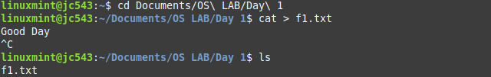

cp : copy files

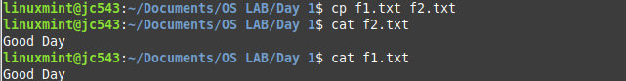

mv : rename files

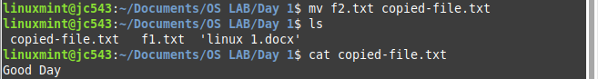

rm : Delete files



cd : Change Directory

pwd : present working directory

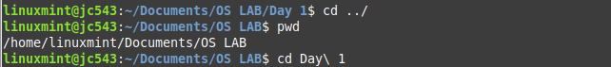

mkdir : Create directory

rmdir : Remove directory

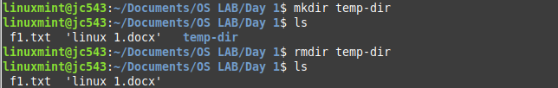

File viewing :

less : Page through files

head : view file beginnng

tail : view file ending

nl : numbering lines

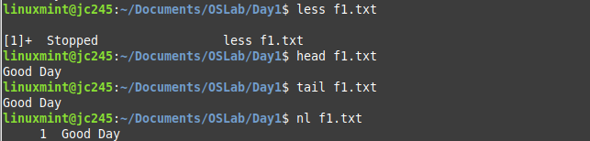

File creation and editing:

umask : set default file protections



File properties :

stat : display file attributes

wc : Count bytes/words/ lines

du : Measure disk usage

file : Identify file types

touch : Change file timestamps

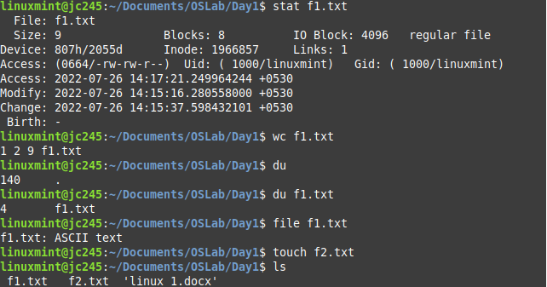

File location:

find : locate files



File Text Manipulation:

grep : Search text for matching lines

sort : sort lines

tee : Copy stdin to a file and stdout simultaneously

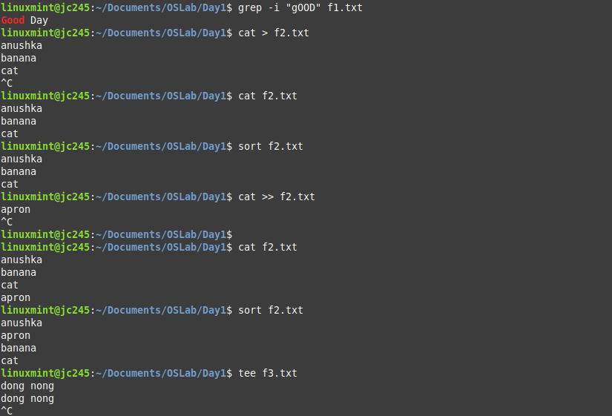

File comparsison :

diff : Compare files line by line

cmp: Compare files byte by byte

Disks and Filesystems:

df : Show disk free space

